Name | RITIK SINGH
UID no. | 2021700061
Experiment No. | 06

AIM: | Prims Algorithm
ALGORITHM/  THEORY: | The working of Prim’s algorithm can be described by using the following steps:  Step 1: Determine an arbitrary vertex as the starting vertex of the MST.  Step 2: Follow steps 3 to 5 till there are vertices that are not included in the MST (known as fringe vertex).  Step 3: Find edges connecting any tree vertex with the fringe vertices.  Step 4: Find the minimum among these edges.  Step 5: Add the chosen edge to the MST if it does not form any cycle.  Step 6: Return the MST and exit
PROGRAM: | #include <stdio.h>  #include <stdlib.h>  #include <stdbool.h>  #include <limits.h>  #define MAX_VERTICES 100 // Maximum number of vertices  #define INF INT_MAX // Infinity  typedef struct {  int u, v, weight; // Edge with vertices u and v and weight w  } Edge;  int parent[MAX_VERTICES]; // Parent of each vertex  Edge edges[MAX_VERTICES]; // Edges in the MST  int num_edges = 0; // Number of edges in the MST  // Find the parent of a vertex  int find(int v) {  if (parent[v] != v) {  parent[v] = find(parent[v]);  }  return parent[v];  }  // Union two sets of vertices  void union_sets(int u, int v) {  parent[find(u)] = find(v);  }  // Comparator function for sorting edges by weight  int compare_edges(const void* a, const void* b) {  Edge* e1 = (Edge*)a;  Edge* e2 = (Edge*)b;  return e1->weight - e2->weight;  }  // Find the MST of a graph with n vertices and m edges  void mst(int n, int m, Edge* edges) {  // Initialize the parent of each vertex to itself  for (int i = 0; i < n; i++) {  parent[i] = i;  }  // Sort the edges by weight  qsort(edges, m, sizeof(Edge), compare_edges);  // Add edges to the MST until all vertices are connected  for (int i = 0; i < m && num_edges < n - 1; i++) {  int u = edges[i].u;  int v = edges[i].v;  if (find(u) != find(v)) {  union_sets(u, v);  edges[num_edges++] = edges[i];  }  }  }  int main() {  int n, m;  printf("Enter the number of vertices: ");  scanf("%d", &n);  printf("Enter the number of edges: ");  scanf("%d", &m);  printf("Enter the edges:\n");  for (int i = 0; i < m; i++) {  scanf("%d%d%d", &edges[i].u, &edges[i].v, &edges[i].weight);  }  mst(n, m, edges);  printf("The MST is:\n");  for (int i = 0; i < num_edges; i++) {  printf("%d - %d: %d\n", edges[i].u, edges[i].v, edges[i].weight);  }  return 0;  }
RESULT:
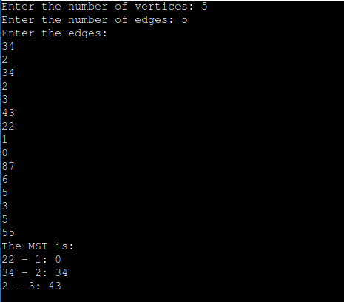
CONCLUSION: | Understood how Prims Algorithm work to find out Minimum Spanning Tree.

